From: https://newrepublic.com/article/126760/fighting-putin-doesnt-make-saint
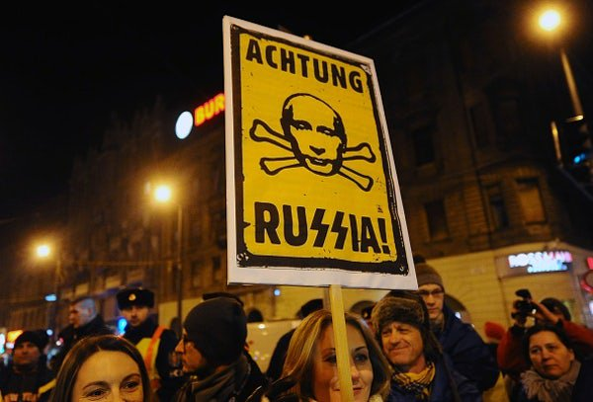
Attila Kisbenedek/Getty

Fighting Putin Doesn’t Make You a Saint

Hedge fund star Bill Browder has been a strident anti-Putin voice. But why won't he testify about Russian wrongdoing?

By JASON MOTLAGH
December 31, 2015
An American-born banker and one-time Putin supporter builds the most successful investment fund in Russia. One day he is declared a threat to national security and kicked out of the country, his company seized by corrupt government officials perpetrating a massive tax fraud scheme. The banker himself is later convicted in absentia of the same offense. But a man he employs, who uncovers the scheme and dares to name names, is arrested. After serving a year in prison he dies under suspicious circumstances. To avenge his loss, the banker morphs from activist financier into an anti-corruption crusader amid death threats from the Kremlin.
MOST POPULAR
This is the origin story at the core of a relentless campaign Bill Browder has spearheaded over the past six years to tighten Western sanctions against Russia. In public appearances, news articles (“The Kremlin threatened to kill me”, “Why I fear for my life”), a memoir, and on a dedicated website, the founder and CEO of Hermitage Capital Management has cultivated official support from London to Washington with astonishing results. In 2012, Congress passed the Magnitsky Act—named after Sergei Magnitsky, the deceased Browder employee—which bans those who benefited from the alleged tax fraud from entering the United States or using its banks. A year later, the U.S. Justice Department doubled-down by opening a civil forfeiture case against a holding company owned by a Russian businessman allegedly linked to the stolen money. Some $22 million of property assets in Manhattan were frozen on charges of money laundering.
Few would dispute that Browder’s staggering success as an outsider money manager could make him a target in the murky realm of post-Soviet Russian finance. Many prominent Russian tycoons have fared worse. Yet attorneys for Denis Katsyv, the Moscow-based businessman who has been snared in the Justice Department’s case, counter that overzealous prosecutors have gone too far, accepting Browder’s account wholesale without independently verifying key details. They assert that a closer examination has revealed holes in his story, ones the government would rather avoid confronting given how much their case depends on Browder’s word.
Katsyv, the 38-year-old son of a former Moscow region transport minister, was first linked to the money-laundering scheme back in September 2013, when the U.S. district attorney for the southern district of New York alleged companies he controls had bought real estate in New York City with some of the $230 million looted from the Russian government. Prosecutors say the cash was siphoned through a tangled web of shell companies with bank accounts in Russia and Eastern Europe, before a portion made its way to an investment company based in Cyprus, Prevezon Holdings, which Katsyv subsequently purchased.
Previous media investigations and insider leaks have suggested the involvement of Russian tax officials in the purported treasury heist. However, no proof has yet surfaced that Katsyv or his family ever profited from, or knew about, the wide-ranging scam, according to his lawyers. They note that Katsyv had no reason to suspect any of the cash was potentially tainted because the transfers were relatively small and pre-dated his ownership of the company.
Last year, U.S. District Judge Thomas P. Griesa loosened the freeze order on most of the real estate assets belonging to companies owned by Katsyv, who has since mounted his own offensive. In May, his lawyers filed a deposition transcript with the Manhattan federal court alleging that key parts of Browder’s story are false. Notably, that his expulsion from Russia was not politically motivated as he has long maintained. In a letter to Judge Griesa, the lawyers wrote that Browder acknowledged under oath he had he “personally signed income tax returns that Russian tax courts found to contain false representations.” They also said Browder did not deny claims his representatives had tried to bribe a Russian journalist who spoke with Magnitsky in prison and was told by him that bosses at Hermitage “set him up” to take the fall for Browder’s alleged tax fraud.
Browder declined to comment for this story. In a May 13 Wall Street Journal article on challenges to his credibility, he said Katsyv’s lawyers had misrepresented his testimony about his tax returns and dismissed the bribery claims. “The defendants,” he asserted by email, “are obviously very upset that we informed the government about their alleged money laundering activity and seem to be trying to attack the people who informed on them as opposed to trying to defend themselves against the very serious allegations brought by the U.S. government.”
Although Browder has been a willing interview in the press, getting him to make his case under oath has been a story in its own right. Browder gave up his U.S. citizenship in 1998 and has lived in the U.K. since leaving Russia. After a lengthy search, a process server finally managed to surprise him last summer in Aspen, Colorado, where he had given a speech. (A judge ruled the summons was not served properly due to lack of residence). Six months later, another server caught up with Browder in New York following an appearance on The Daily Show. When he charged forward to present subpoena papers, Browder slipped out of the side of his limousine and fled on foot. (The incident was captured on video). This time the judge ruled the subpoena was valid and the financier was deposed.
Browder’s lawyers have fought for nearly two years to keep their client from being cross-examined. For the defense, such elusive behavior raises a fair question: If Browder was indeed the victim of persecution in Russia and has enlisted the U.S. justice system to right the balance, why is he so reluctant to offer his sworn testimony in an American courtroom?
Katsyv’s lawyers say the government has acknowledged that Browder was the main source of its allegations and is now avoiding a hostile cross-examination that would test the veracity of his allegations. “In any media space where Browder has promulgated his story, there is no one who would ask the kind of concrete, pointed questions he would need to answer without contradicting his previous statements,” Natalia Veselnitskaya, a Russian lawyer representing Katsyv, told me. “How can a person who does not pay taxes [in the U.S.] have this kind of influence?”
This dizzying legal drama might be forgettable had Browder’s lobbying efforts not had major foreign policy implications. In the wake of the Magnitsky Act, the Russian government banned Americans from adopting Russian children and drew up a blacklist of its own against U.S. officials, deepening a diplomatic row that some have likened to a new Cold War. While the U.S. government has every reason to track dirty foreign money with a history of flowing into the New York real estate market, lawyers for Prevezon say the stakes are too high to be hinged on one man’s account.
The U.S. Attorney’s case was scheduled to go to trial in early January, but has been delayed by motions made by Browder’s lawyers. Whenever the case is finally heard in court, it’s still not clear whether he will take the stand to testify. With all the favorable results his stateside advocacy has mustered since his ouster from Russia, the looming question is: Why not?
Jason Motlagh is an international reporting fellow with the Pulitzer Center. He has written for National Geographic, Outside, The Washington Post, and The Guardian. This story was reported with an immigration journalism grant from the French-American Foundation, where he is also a fellow.

[This article was references as a "Thoughtful piece" by Israel Shamir in his June 20, 2016 article "The Untouchable Mr. Browder". –FNC]]

